**Resultados Preliminares**

***Procedimiento de Análisis de Datos:***

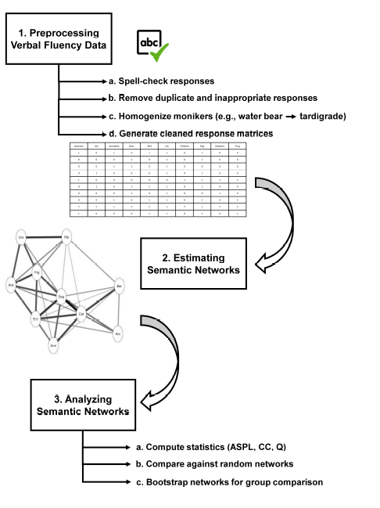

Christensen, A. P., & Kenett, Y. N. (2021). Semantic network analysis (SemNA): A tutorial on preprocessing, estimating, and analyzing semantic networks. *Psychological Methods.* Advance online publication. [https://doi.org/10.1037/met0000463](https://doi.apa.org/doi/10.1037/met0000463)

**Network Estimation Methods**

Correlation-based Network (CbN) methods constructs a semantic network based on the co-occurrence of

responses across the response matrix. Using the binary response matrix, the CbN methods compute an

association measure between every pair of responses, resulting in an association matrix. Most often, these

association matrices are estimated using Pearson’s correlation (Kenett et al., 2013); however, any association

measure could be used. In the original study that used our example data, for example, cosine similarity was

used to avoid negative associations between nodes in the network (for binary values, cosine similarity ranges

from zero to one; Christensen, Kenett, Cotter, Beaty, & Silvia, 2018). The association measure is therefore a

parameter (“Association Measure”) that can be manipulated with CbN; however, Pearson’s correlation and

cosine similarity are recommended.

Massara, G. P., Di Matteo, T., & Aste, T. (2016). Network filtering for big data: Triangulated maximally filtered graph. Journal of Complex Networks, 5, 161–178. <https://doi.org/10.1093/comnet/cnw015>

**Global Network Measures:**

These measures focus on the structure of the entire network, emphasizing how nodes are connected

as a cohesive whole (Siew, 2019).

A common network structure that tends to emerge across many different systems (including semantic memory)

is a small-world structure (Kenett, Anaki, & Faust, 2014; Lerner, Ogrocki, & Thomas, 2009; Watts & Strogatz,

1998). Small-world networks are characterized by having a moderate average shortest path length (ASPL)

and large clustering coefficient (CC). **The ASPL refers to the average shortest number of steps (i.e., edges)**

**that is needed to get between any pair of nodes in the network. That is, it’s the average of the minimum**

**number of steps from one node to all other nodes. In cognitive models, ASPL may affect the activation of**

**associations between concepts (known as *spreading activation*; Anderson, 1983; Siew, 2019) such that a lower**

**ASPL would increase the likelihood of reaching a greater number associations (Christensen, Kenett, Cotter,**

**Beaty, & Silvia, 2018).** Several studies of creative ability and semantic networks have linked lower ASPL to

greater creative ability (Benedek et al., 2017; Kenett, Anaki, & Faust, 2014; Kenett & Faust, 2019; but see,

Lange, Hopman, Zemla, & Austerweil, 2020). These studies have argued that the lower ASPL in the semantic

network of people with higher creative ability may have allowed them to reach more remote associations,

which in turn could be combined into novel and useful associations (Kenett & Faust, 2019).

**The clustering coefficient (CC) refers to the extent that two neighbors of a node will be neighbors themselves, on average, in the network. A network with a higher CC, for example, suggests that nodes that are near-neighbors to each other tend to also co-occur and be connected**. **Wulff, Hills, and Mata (2018) examined younger and older adults semantic networks that were estimated using category verbal fluency data and found that the older adults had a smaller CC compared to the younger adults. This structure was interpreted as having a role in the**

**cognitive slowing observed in older adults.**

**Finally, modularity measures how well a network compartmentalizes (or partitions) into sub-networks (i.e.,**

**smaller networks within the overall network; Fortunato, 2010; Newman, 2006).** The maximum modularity

coefficient (Q) estimates the extent to which the network has dense connections between nodes within a

sub-network and sparse (or few) connections between nodes in different sub-networks. In this implementation,

Q refers to the maximum modularity possible given all possible partition organizations. **Higher Q values suggest that these sub-networks are more well-defined, while lower Q values suggest that the network may be less readily segmented into different parts.**

Massara, G. P., Di Matteo, T., & Aste, T. (2016). Network filtering for big data: Triangulated maximally filtered graph. Journal of Complex Networks, 5, 161–178. <https://doi.org/10.1093/comnet/cnw015>

**Bootstrap Analyses**

To statistically compare semantic networks applies a bootstrap method (Efron, 1979). There are two bootstrap approaches that can be applied in the SemNA pipeline: case-wise and node-wisenbootstrap. For each replicate sample, the network estimation method is applied and then the global network measures—ASPL, CC, and Q—are computed. This process repeats iteratively (1,000 times).

These bootstrap networks form sampling distributions of the global network measures, but solely based on the empirical data. These sampling distributions can then be statistically compared with a *t*-test if there are only two groups being compared. If there are two or more groups, then an analysis of covariance (ANCOVA) with the number of edges used as a covariate can be used to estimating whether the global network measures are different between each group’s networks. Including edges as a covariate statistically controls for a confound that affects comparing network measures between groups. ASPL, for example, will often be smaller for networks with a greater ratio of edges to nodes (van Wijk, Stam, & Daffertshofer, 2010). Adjusted means and effect sizes that account for this confound are then estimated.

Effect sizes (d): small (.20), medium (.50), and large (.80): Cohen, J. (1988). Statistical power analysis for the behavioural sciences (2nd ed.). New York, NY: Routledge. https://doi.org/10.4324/9780203771587

Effect sizes (ηp2): small (.01), medium (.06), and large (.14): Cohen, J. (1988). Statistical power analysis for the behavioural sciences (2nd ed.). New York, NY: Routledge. <https://doi.org/10.4324/9780203771587>

Christensen, A. P., Kenett, Y. N., Cotter, K. N., Beaty, R. E., & Silvia, P. J. (2018). Remotely close associations: Openness to experience and semantic memory structure. European Journal of Personality, 32, 480–492. <https://doi.org/10.1002/per.2157>

Kenett, Y. N., Wechsler-Kashi, D., Kenett, D. Y., Schwartz, R. G., Ben Jacob, E., & Faust, M. (2013). Semantic organization in children with cochlear implants: Computational analysis of verbal fluency. Frontiers in Psychology, 4, 543. <https://doi.org/10.3389/fpsyg.2013.00543>